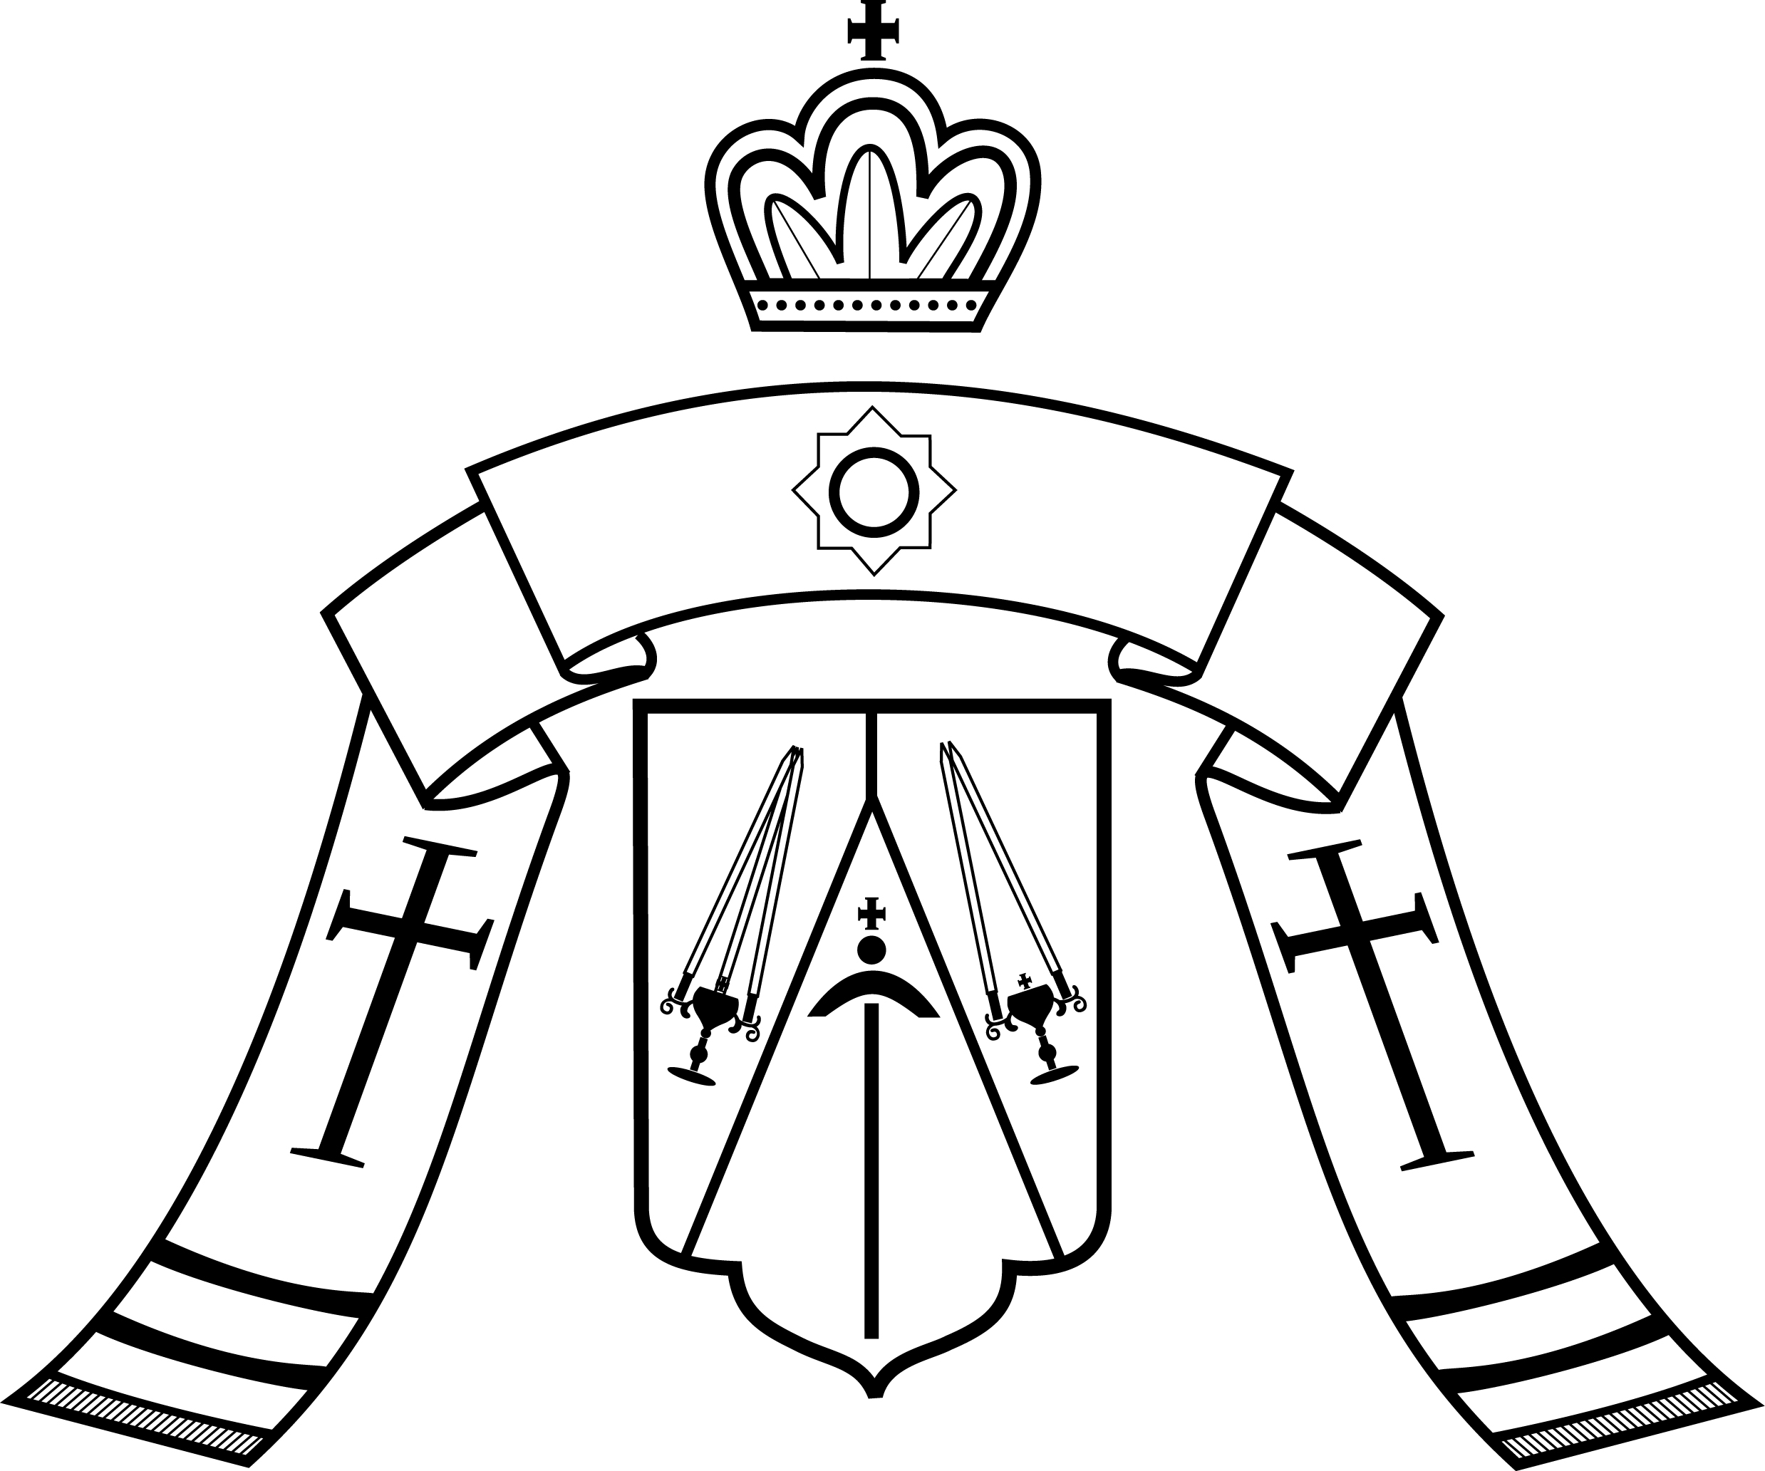
Reverend Fathers, Venerable Monastics, and Pious Faithful
of the Western American Diocese ROCOR:

CHRIST IS RISEN!

These words, delivered by an Angel to the Myrrh-bearing Women, came to man in an hour of profound darkness. The human race grieved at the grave-side of its Saviour. The earth, and even the sun, trembled at the gravity of man’s sin. Godlessness seemed, for a moment, to reign; and the centurion’s awe-struck cry at the Cross, “Surely this man was the Son of God” (Matthew 27:54) only emphasised the tragedy of what had taken place: man had striven to supplant God, to kill what was good and right, and to set up his own will in place of the Divine Will of the Creator.

But the Angel cried out: “Christ is risen!” The Angel cried out in the midst of that darkness, and the darkness changed to light. We call Pascha the “Bright Feast” of the Resurrection, because a Light has truly “shone in the darkness, and the darkness did not overcome it” (John 1:5). It was not able to overcome it, and it never shall — not in that day, not in ours, not in any other.

One hundred years ago, man again tried to give reign to the darkness in his sinful heart. We commemorate this year the centennial of the tragedy of 1917, when Godly rule was overturned in Holy Russia by the machinations of men. A divinely-appointed Monarch, who would show himself to be a saint, a Passion-bearer, and a pious martyr, was forced from his throne. The Will of God was cast aside, and, it seemed, human intentions prevailed. We do not remember this date as an “Anniversary” in a normal, joyful sense, but as a dark hour of tragedy, and one that shaped our lives directly, and still does. Yet even here, the Lord transforms sorrow into joy. As godlessness strove to gain the upper hand in Russia, as the faithless of the twentieth century sought to cry out together with the faithless of the first century, that God was dead, the Angel delivered again his divine message: “Christ is risen!” We saw Him rise in power in Russia, in our own day and with our own eyes. We have seen Him call his people again out of darkness, into the light. We pray that His Divine Will for right reign and rule will yet rise forth from the ashes, that a Godly Monarch may one day again be enthroned over us, and that the last shadows of our sorrow may finally be done away with.

Christ is risen! This is the message that changes the world. It changes history. It changes the universe. And it changes us, each of us, turning us away from our own inner darkness to the Light that never fails. May we rejoice in its power, may we sing out the Lord’s praise, and may we live worthy of rising with Him in glory.

Christ is Risen! Truly, He is Risen!
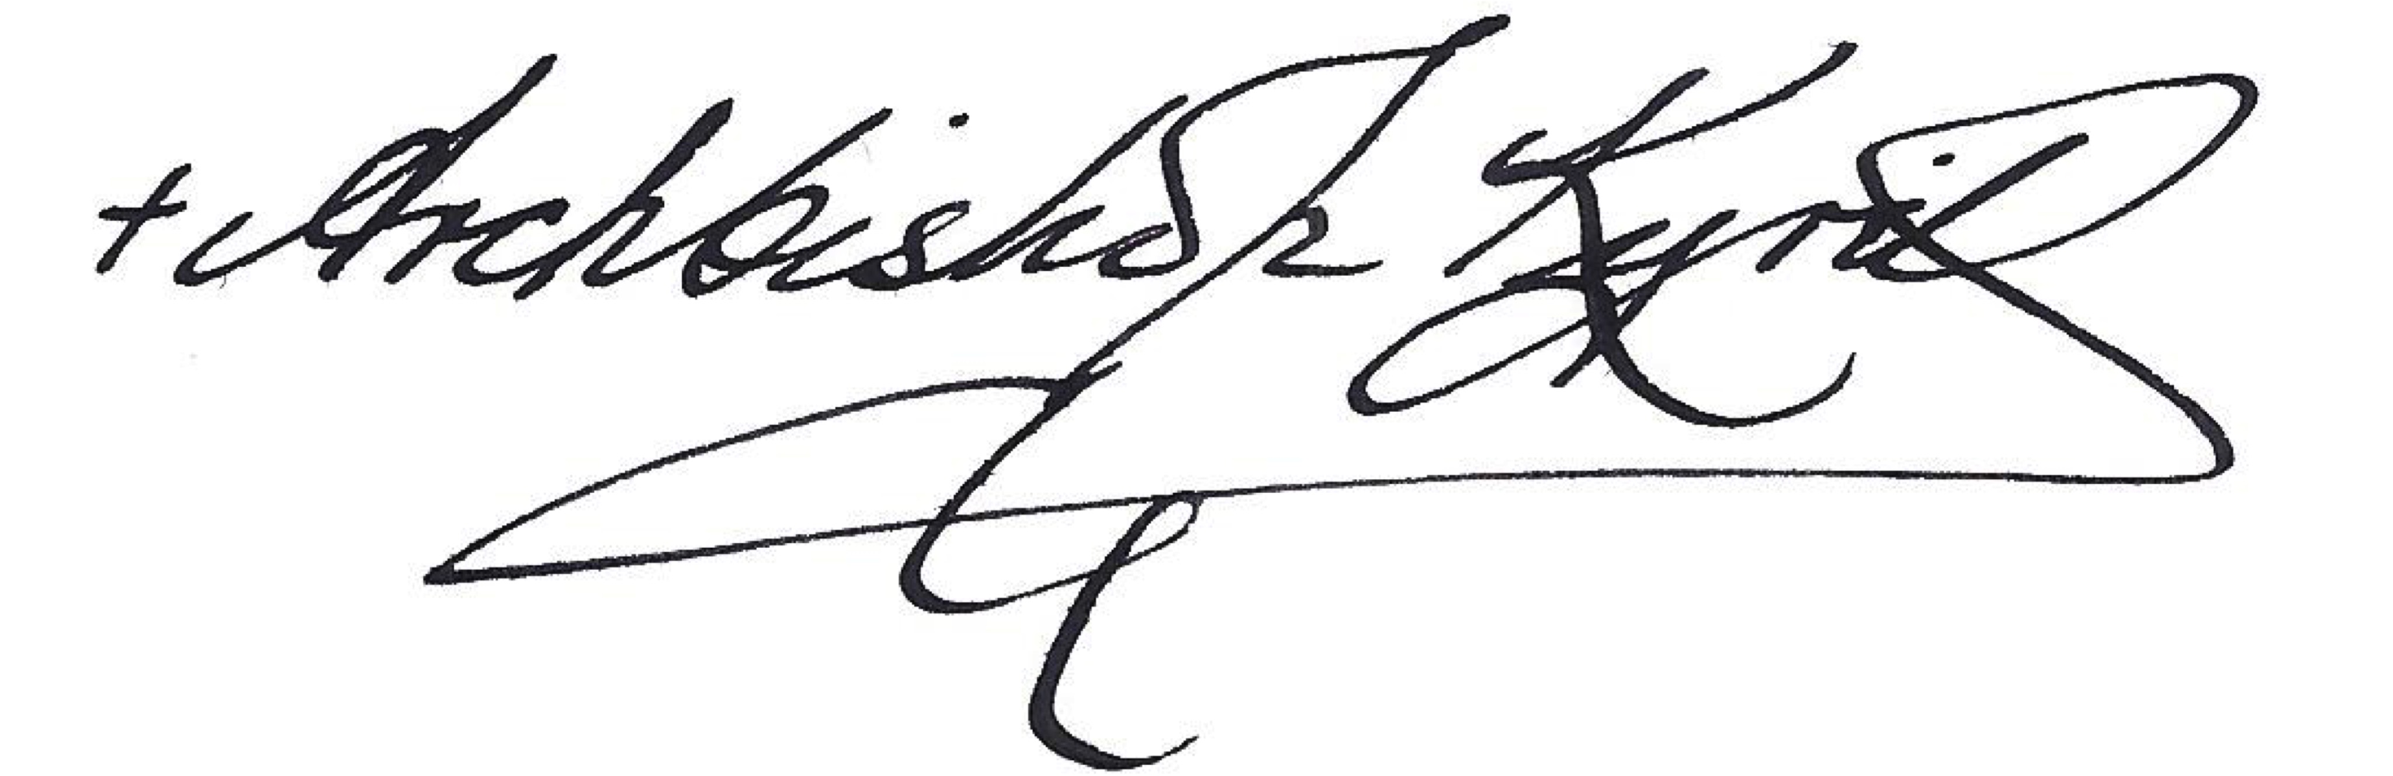

3/17 April 2017

